***B.Tech. Project Report***

**SEISMIC BEHAVIOUR OF MULTISTORIED RC FRAME BUILDINGS WITH BASEMENT STORIES**

**Submitted**

**By**

**Gaurav Mali**

Under the supervision of

**Prof. Kaustubh Dasgupta**



**Department of Civil Engineering**

**Indian Institute of Technology Guwahati**

**May 2022**

**CERTIFICATE**

It is certified that the work contained in the project report entitled “**Seismic Behaviour of Multi-storeyed RC Frame Buildings with Basement Stories**”, by **Gaurav Mali** (180104034)has been carried out under my supervision and that this work has not been submitted elsewhere for the award of a degree or diploma.

**Date: 02/05/2022** Signature

**Prof. Kaustubh Dasgupta**

Department of Civil Engineering

Indian Institute of Technology Guwahati

**DECLARATION**

I Mr. Gaurav Mali (180104034) hereby declare that the comments and suggestions received during BTP evaluation/examination are duly incorporated at suitable places in this report in consultation with my supervisor.

Date: 02/05/2022

**Gaurav Mali**

Countersigned by

Date: 02/05/2022

**Prof. Kaustubh Dasgupta**

Department of Civil Engineering

Indian Institute of Technology Guwahati

**ABSTRACT**

Many multistoried Reinforced Concrete (RC) frame buildings have basement floors, below ground level, for providing parking space and other utilities. It also have significant influence in seismic resistance and providing lateral stiffness to the building. Shear wall also helps in resisting horizontal loading which may be wind load or seismic load. In the present study, the influence of basement on the Seismic Behaviour of multi-storeyed RC Frame Buildings with shear walls and without shear walls is investigated. RC shear walls has an important role specifically in high rise buildings exposed to horizontal seismic and wind loads. In a tall building, earthquake resistance can be achieved by providing proper stiffness, strength and ductility to the structures. In this present work, we have calculated the seismic load on the building with basement and on the building with no basement using Equivalent static method from IS: 1893-2016. Then we performed linear static analysis on both the buildings to obtain the loads and moments, from which we designed the members of both the buildings using IS: 456-2000 and IS: 13920-2016. Then we performed the non-linear (Pushover) analysis to determine the shear capacity of the buildings and finding the failure mode.

**ACKNOWLEDGEMENT**

To begin, I'd like to show my gratitude to Dr. Kaustubh Dasgupta, professor at IIT Guwahati's Department of Civil Engineering and also my supervisor, who has helped me through several tasks during this project. I sincerely thank him for his unwavering support and encouragement, which has enabled me to expand my expertise in this subject. I'd also like to express my gratitude to the Civil Engineering Department's lecturers and personnel for their assistance with my thesis. They helped me compile and prepare this project report by providing me with excellent information, suggestions, and guidance.

**Date: 02/05/2022**

**Gaurav Mali**

|  |  |  |
| --- | --- | --- |
| **TABLE OF CONTENTS** | | |
| **Page no.** | | |
| **Certificate** | | ii |
| **Declaration** | | iii |
| **Abstract** | | iv |
| **Acknowledgement** | | v |
| **List of Symbols and Abbreviations** | | viii |
| **List of Tables** | | ix |
| **List of Figures** | | x |
|  | |  |
| **Chapter 1: Introduction** | | **1** |
|  | 1.1 Background | 1 |
|  | 1.2 Objective | 2 |
| **Chapter 2**: **Literature Review** | | **3** |
|  | 2.1 Past Study | 3 |
|  | 2.1.1 Study on Basement Walls | 3 |
|  | 2.1.2 Study on Composite beams and columns | 7 |
|  | 2.1.3 Study on Soil Structure Interaction | 10 |
|  | 2.2 Gap Areas | 15 |
|  | 2.3 Scope of Work | 15 |
| **Chapter 3**: **Methodology** | | **16** |
| 3.1 Modeling and Analysis | | 16 |
|  | 3.1.1 Building without Basement | 16 |
|  | 3.1.2 Building with Basement | 17 |
| **Chapter 4: Results** | | **20** |
| 4.1 Base Shear for both the cases | | 20 |
| 4.2 Building without Basement | | 20 |
|  | 4.2.1 Design of beams and columns from ground to 2nd floor | 20 |
|  | 4.2.2 Design of beams and columns from 3rd to 5th floor | 21 |
| 4.3 Building with Basement | | 23 |
|  | 4.3.1 Design of beams and columns for and above ground floor | 23 |
|  | 4.3.2 Design of beams and columns for basement floors | 25 |
| 4.4 Pushover Analysis | | 27 |
|  | 4.4.1 For building without basement stories | 27 |
|  |  |  |
| **Chapter 5: Summary** | | **29** |
| 5.1 Conclusion | | 29 |
| 5.2 Future scope of work | | 29 |
| **References** | | **30** |
| **Annexure A** | | **31** |
| A-1 Various Checks | | 31 |
|  | A-1.1 Check for Axial Stress | 31 |
|  | A-1.2 Check for Member size | 31 |
|  | A-1.3 Check for limiting longitudinal reinforcement | 31 |
| A-2 Design of Flexure | | 32 |
| A-3 Design of Shear | | 33 |
| **Annexure B** | | **37** |
| B-1 Various Checks | | 37 |
|  | B-1.1 Check for Member size | 37 |
|  | B-1.2 Check for limiting longitudinal reinforcement | 37 |
| B-2 Design of Column | | 38 |
|  | B-2.1 Checking for Critical combination with earthquake in X direction (Longitudinal direction) | 39 |
|  | B-2.2 Checking for Critical combination with earthquake in Y direction (Transverse direction) | 41 |
| B-3 Design of Shear | | 42 |
|  | B-3.1 Shear Force due to plastic hinge formation at ends of beam | 42 |
|  | B-3.2 Design Shear | 43 |
|  | B-3.3 Detailing of Transverse reinforcement | 43 |
|  | |  |

**List of Symbols and Abbreviations**

|  |  |
| --- | --- |
| **Symbol** | **Description** |
| RC | Reinforced Concrete |
| BCR | Basement coverage ratio |
|  | Relative density |
| PGA | Peak ground acceleration |
| SRC | Steel reinforced columns |
| SPRSW | Steel plate reinforced shear walls |
| SSI | Soil-structure interaction |
| MA | Most accurate |
| M–O | Mononobe–Okabe |

|  |  |  |
| --- | --- | --- |
|  | **List of Tables** |  |
| **Table No.** | **Title** | **Page No.** |
| 2.1 | Summary of the investigated parameters (Mansour et al., 2021) | 5 |

|  |  |  |
| --- | --- | --- |
|  | **List of Figures** |  |
| **Figure No.** | **Title** | **Page No.** |
| 1.1 | Lateral load transfer mechanism in a RC frame-wall building with basement stories (ATC, 2010) | 2 |
| 2.1 | Problem configuration for BCR of 100% (all dimensions are in meters) (Mansour et al., 2021) | 4 |
| 2.2 | Acceleration time history of the Loma Prieta 1989 Earthquake (Mansour et al., 2021) | 4 |
| 2.3 | Artificial earthquake record with duration of 20 s and PGA of 0.15 g. (Mansour et al., 2021) | 5 |
| 2.4 | Static and resultant earth pressure envelope for PGA of 0.15 g and BCR of 100% (Mansour et al., 2021) | 6 |
| 2.5 | Seismic earth pressure envelope for PGA of 0.10 g. (Mansour et al., 2021) | 6 |
| 2.6 | Fiber beam-column element (Ren et al., 2017) | 8 |
| 2.7 | Multilayer shell element (Ren et al., 2017) | 8 |
| 2.8 | The plane layout and elevation of a 20-story tall building (Ren et al., 2017) | 8 |
| 2.9 | Details of typical reinforced concrete members. RC (reinforced concrete) (Ren et al., 2017) | 9 |
| 2.10 | Details of steel reinforced column (SRC) (Ren et al., 2017) | 9 |
| 2.11 | Detailed of steel plate reinforced shear wall (Ren et al., 2017) | 9 |
| 2.12 | Inter-story drift ratio (PGA = 400 ) (Ren et al., 2017) | 10 |
| 2.13 | Most accurate model of a 54-storey building (Finn et al., 2011) | 11 |
| 2.14 | Simplest model of building with no soil–structure interaction (Finn et al., 2011) | 12 |
| 2.15 | Drift ratios for models MA and first model (Finn et al., 2011) | 12 |
| 2.16 | Second Model (Finn et al., 2011) | 13 |
| 2.17 | Drift ratios for models MA and second model (Finn et al., 2011) | 13 |
| 2.18 | Third Model (Finn et al., 2011) | 13 |
| 2.19 | Drift ratios for models MA and third model (Finn et al., 2011) | 13 |
| 2.20 | Time history of maximum force against the wall compare with M–O seismic forces (Finn et al., 2011) | 14 |
| 2.21 | Distribution of the design lateral pressure along the height of the wall based on the current practice for a seismic event with PGA = 0.24 g and a backfill soil with friction angle of 3 (Finn et al., 2011) | 14 |
| 2.22 | Pressure distribution at time of maximum force on the wall compared with linear Mononobe–Okabe maximum pressure (Finn et al., 2011) | 14 |
| 3.1 | SAP 2000 model of five storied RC frame building with no basement | 17 |
| 3.2 | SAP 2000 model of five storied RC frame building with three basement stories | 18 |
| 3.3 | Five-storied RC frame building with basement stories: (a) typical floor plan in superstructure and (b) elevational view | 19 |
| 4.1 | Detailing for beams from ground floor to 2nd floor | 20 |
| 4.2 | Cross sections of beams from ground floor to 2nd floor at different locations | 21 |
| 4.3 | Detailing for Columns from ground floor to 2nd floor | 21 |
| 4.4 | Detailing for beams from 3rd floor to 5th floor | 22 |
| 4.5 | Cross sections of beams from 3rd floor to 5th floor at different locations | 22 |
| 4.6 | Detailing for Columns from 3rd floor to 5th floor | 23 |
| 4.7 | Detailing for beams for above the ground floor | 23 |
| 4.8 | Cross sections of beams at different locations for above the ground floor | 24 |
| 4.9 | Detailing for Columns for above the ground floor | 24 |
| 4.10 | Detailing for beams for all the basement floors | 25 |
| 4.11 | Cross sections of beams at different locations for all the basement floors | 25 |
| 4.12 | Detailing for Columns for all the basement floors | 26 |
| 4.13 | Deflected shape of the RC frame building with basement stories for seismic load along X-direction: (a) 3-D view of deflected shape and (b) side view of deflected shape. | 26 |
| 4.14 | Pushover curve: Base reaction vs displacement | 27 |
| 4.15 | Deflected shape of the RC frame building with basement stories for pushover analysis at step 994. | 28 |
|  |  |  |
|  |  |  |
|  |  |  |

**Chapter 1**

**Introduction**

**1.1 Background**

In urban areas, multistoried Reinforced Concrete (RC) frame buildings have with basement floors, below ground level, for providing parking space and other utilities. These stories can extend upto significant depth below ground level. In order to increase the strength and stability of the underground part of the building, RC shear walls are provided along perimeter of the building as well as along the intermediate length and width. During earthquake shaking, such basement walls tend to provide significant lateral stiffness and lateral strength by virtue of its box-type rigidity. The transfer of forces from the superstructure to the basement part determines the overall seismic behaviour.

Generally, tall RC frame buildings are provided with structural walls or shear walls in earthquake-prone areas to impart for large lateral strength and lateral stiffness to the building. However, multistoried RC frame buildings of shorter heights may not be provided with shear walls. For RC frame-wall buildings with basement stories, two distinct regions of seismic behaviour can be observed (Fig. 1.1). The superstructure part which is located above the ground level, experiences large lateral loads during the earthquake shaking and the below-grade or podium portion is subjected to the backstay effect. Backstay effect is the transfer of lateral loads through diaphragms to foundation and the walls. Most of the load transfer takes place is main backstay diaphragm and load transfer in other various diaphragms varies according to different stiffness at different levels.

Elements comprising podium include (i) RC perimeter walls which are also subjected to earth pressure from the adjacent soil. from surrounding soil, (ii) floor diaphragms which help in transfer of lateral loads, (iii) foundation and (iv) supporting soil, both of which help in providing the resisting moments during the building shaking.

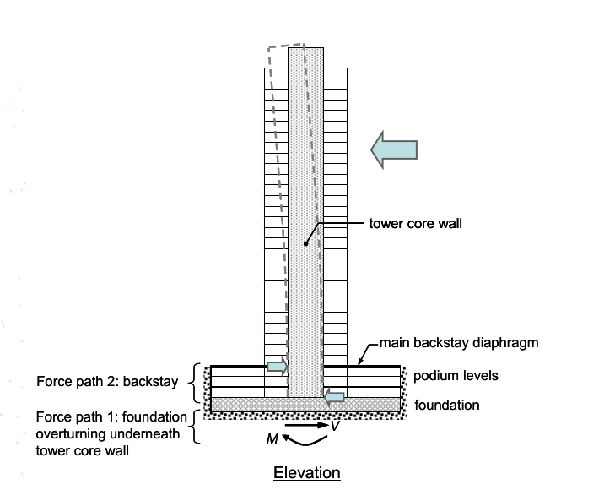

**Fig. 1.1** Lateral load transfer mechanism in a RC frame-wall building with basement stories (ATC, 2010)

Thus, the structural design of a building with basement stories involves consideration of both the aspects of lateral load transfer mechanism. For two tall buildings sharing the same basement portion, earthquake shaking results in unsynchronized movement of the two superstructures. To obtain proper behaviour in that case, detailed nonlinear dynamic analysis needs to be carried out.

Very few studies on the influence of soil-structure interaction on building behaviour with basement stories have not been carried out. In Indian context, detailed study on seismic behaviour of such buildings has also not been carried out.

**1.2 Objective**

(a) To study the seismic behaviour of RC frame building with basement walls, designed as per the Indian Standards of Practice

(b) To provide possible guidelines on configuration of such buildings from earthquake resistance point of view.

**Chapter 2**

**Literature Review**

**2.1 Past Study**

**2.1.1 Study on Basement Walls**

The increasing need for creating underground basements in seismic regions has led to development in research on seismic response of basement walls. The seismic response of basement walls is explored by building a numerical model using the finite difference approach, which simulates the interaction between the basement wall, backfill, and foundation soils (which are made up of dry thick soil), as well as bedrock motion. The connection between peak acceleration response and peak seismic thrust and straining actions is demonstrated in this work, which aids seismic design when empirical correlations are developed. Additional inertial forces are produced by earthquakes as a result of the earthquake's acceleration and the bulk of the retained dirt. To account for the seismic extra forces on retaining walls, many methods are utilized, ranging from the pseudo-static method to advanced dynamic analysis based on the earthquake's actual acceleration time history. Basement walls are constrained at the top and bottom, yet flexural stiffness allows them to move throughout their height. The research in this publication takes into account both full and partial basement coverage of the structure's footprint. The basement of a multi-story structure is modelled to take up 20, 40, 60, or 100 percent of the total structure's footprint. A simulated earthquake time history at the top of bedrock represents seismic excitation.

The modelled structure is a four-story structure with a floor height of 3.0 m, a width of 20.0 m dispersed across five equal spans of 4.0 m, column dimensions of 0.3 x 0.6 m, and a roof slab thickness of 0.2 m. The live load on the roof slabs is 5 kPa, while the floor cover is 2.5 kPa. The superstructure is supported by strip footings with a width of 1.0 m and a thickness of 0.5 m, a tie beam with a dimension of 0.3x0.8 m, and a bearing pressure of 320 kPa. The thickness of basement walls ranges from 0.2 to 0.5 m, and the depth of bedrock beneath the foundation varies from 10 to 25 m.

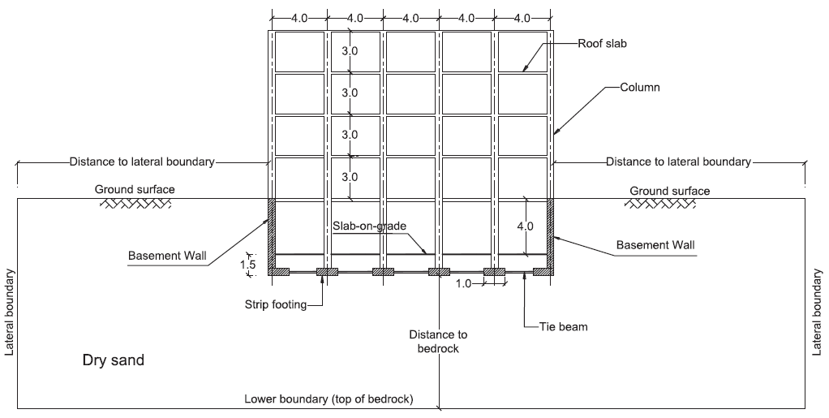

**Fig. 2.1** Problem configuration for BCR of 100% (all dimensions are in meters) (Mansour et al., 2021)

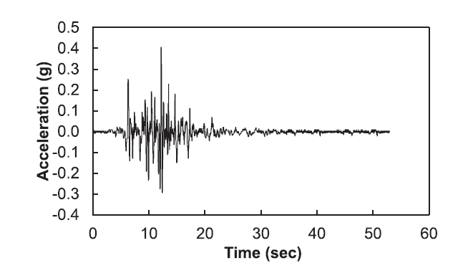To mimic the interaction between basement walls and dry Nevada Sand of relative density (D_r) 75%, a fully instrumented centrifuge model was created. It was subjected to the Loma Prieta 1989 earthquake's acceleration time history. The acceleration time history of the Loma Prieta 1989 earthquake is represented in (Fig.2.2).

**Fig. 2.2** Acceleration time history of the Loma Prieta 1989 Earthquake (Mansour et al., 2021)

Seismic loading is represented by artificial earthquake time history based on the Uniform Building Code. Earthquake duration and peak ground acceleration (PGA) was taken as 20 sec and 0.15 g respectively.

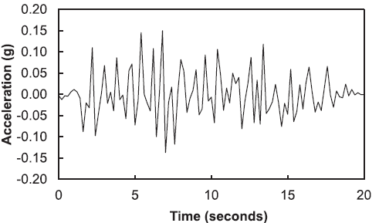

**Fig. 2.3** Artificial earthquake record with duration of 20 s and PGA of 0.15 g. (Mansour et al., 2021)

Parameters and their range are shown in the (Table 2.1). The backfill and foundations soil is dry dense sand having an internal friction angle of .

**Table 2.1** Summary of the investigated parameters. (Mansour et al., 2021)

|  |  |
| --- | --- |
| **Parameter** | **Range** |
| PGA at bedrock (g)  BCR (%)  Basement wall thickness (t, m)  Bedrock depth (m)  Basement clear height (m) | 0.10, 0.125, 0.15, 0.20  100, 60, 40, 20  0.2, 0.3, 0.4, 0.5  10, 15, 20, 25  3, 4, 5 |

Considering PGA from 0.10 to 0.20 g for BCR of 100, 60, 40, and 20% and basement wall thickness, clear height, and bedrock depth of 0.3 m, 4 m, and 20 m, respectively, the effect of PGA on seismic earth pressure response was discovered. The resultant earth pressure envelope and static earth pressure distribution with PGA of 0.15 g and BCR of 100 percent are shown in Figure 2.4.

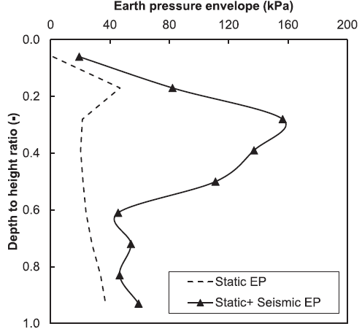

**Fig. 2.4** Static and resultant earth pressure envelope for PGA of 0.15 g and BCR of 100% (Mansour et al., 2021)

The study presents a seismic design framework for basement walls that takes into account the whole interaction of basement walls with backfill and foundation soils. It is a set of empirical linear/bilinear equations that show the upper and lower bounds of peak seismic thrust, bending moment, and shear force as a function of peak acceleration response, which equals the PGA at bedrock multiplied by an amplification factor ranging from 1.65 to 2.3 for the studied cases. The clear height above the basement floor level, or 0.72 times the total wall height above the wall bottom, is where seismic pressure on basement walls peaks.

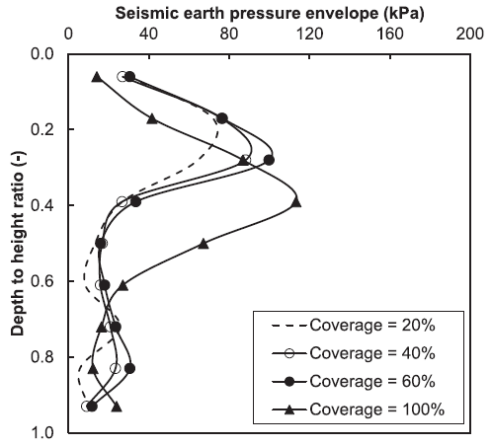

**Fig. 2.5** Seismic earth pressure envelope for PGA of 0.10 g. (Mansour et al., 2021)

**2.1.2 Study on Composite beam and column**

Tall buildings are frequently subjected to lateral loads such as wind and earthquakes, hence reinforced concrete columns and shear walls are employed to counteract these lateral loads. To assure ductility of reinforced concrete columns and walls, design regulations set a maximum axial force ratio. To sustain high levels of axial stresses at the lower stories of tall structures, RC columns and shear walls are designed with larger cross sections and dense stirrups. The service space is occupied by large columns and thick walls, which increases the inertial force caused by earthquakes. In the field, dense stirrups are similarly difficult to construct. To avoid these issues, a composite structural member that combines the benefits of both steel and RC members can be used. Many composite structural members outperform RC or steel members in terms of performance. Reinforced concrete increases stiffness and avoids buckling of steel members in composite structural members, while the steel member improves the bearing capacity and ductility of the composite structural member. Improvements in individual structural parts may not result in improvements in the whole structure at a nonlinear stage during a major earthquake unless the structure is properly planned. Here, a computational investigation is performed to seismic nonlinear performance of tall building with/without composite columns and shear walls.

The nonlinear behaviors for the steel used in building structure is governed by plasticity. Damage-plasticity models is used to reproduce the nonlinear behaviors of concrete under multidimensional stress conditions. Finite element simulation of tall buildings is commonly based on structural elements, like beam element, shell element. The interaction of steel and concrete has been thoroughly researched in structural elements. For beams and columns, a displacement-based fibre beam-column element is used, as well as a multilayer shell element for shear walls. The fibre beam-column element model is widely utilized because to its careful balance of accuracy and cost. The segment corresponding to the integration point is divided into fibres while studying the interaction between bending moment and axial force of beam-columns that are experiencing substantial nonlinearity. The strain of each fibre over the section could be estimated using the Euler–Bernoulli hypothesis based on section deformations such as curvature and axial strain. Composite shell element or laminated shell element are other names for multilayer shell element. According to multilayer formulation, the local shell section is divided into a number of layers with different thickness and material properties. The bond-slip between concrete and steel for both of the fiber beam–column model and the 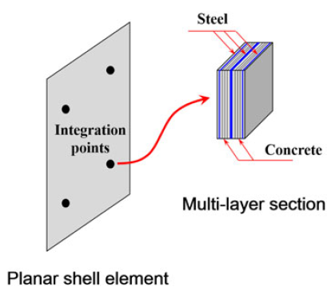multilayer shell model is not considered.

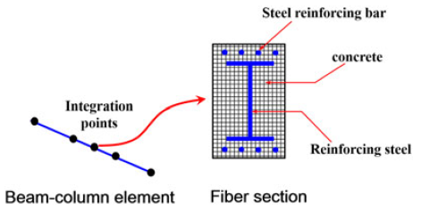**Fig. 2.6** Fiber beam-column element **Fig. 2.7** Multilayer shell element (Ren et al., 2017) (Ren et al., 2017)

A 20-story tall building with a total height of 81.2 metres, 20 levels above ground, and one basement is depicted below in plan and elevation. A frame column's cross section is 900 mm x 900 mm, a beam section is 400 mm x 800 mm, the thickness of the tube shear wall is 400 mm, the thickness of the inner shear wall is 250 mm, and the thickness of the regular plates for each level is 120 mm. 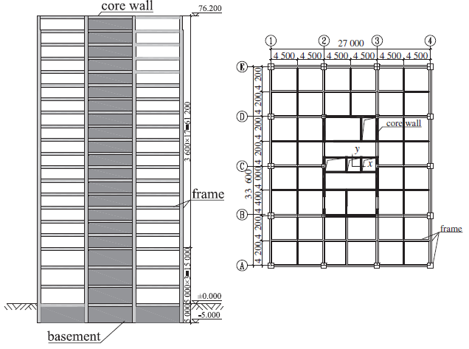

**Fig. 2.8** The plane layout and elevation of a 20-story tall building (Ren et al., 2017)

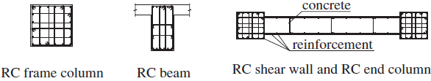Four structural design schemes are considered for comparative studies of the seismic behaviors for different structures. Scheme A: Regular RC is considered. Scheme B: RC with steel reinforced columns (SRC) is considered. Here, RC columns from the basement to the top is enhanced by structural steel. Scheme C: RC with steel plate reinforced shear walls (SPRSW). Scheme D: RC with SRC and SPRSW.

**Fig. 2.9** Details of typical reinforced concrete members. RC (reinforced concrete) (Ren et al., 2017)

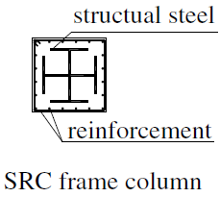

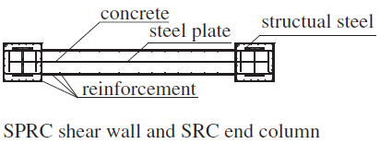

**Fig. 2.10** Details of steel reinforced column (SRC) (Ren et al., 2017) **Fig. 2.11** Detailed of steel plate reinforced shear wall (Ren et al., 2017)

Four strong earthquake records, for example, the El Centro record, the Taft record, the ChiChi‐1404 record, and the ChiChi‐1502 record, with their NS and EW components are considered. In order to study the nonlinear performance of tall building, structures are subjected to intensities of severe earthquakes, PGA for each record is scaled to 400 and 620 cm/, respectively.

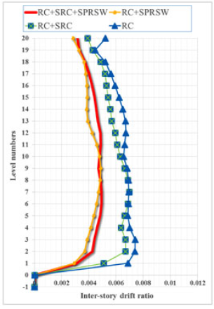

**Fig. 2.12** Inter-story drift ratio (PGA = 400 ). (Ren et al., 2017)

Due to nonlinearities and the resulting redistribution of internal force, strengthening individual members may not lessen the seismic response of overall structures; yet, extra reinforcing steel plays a vital influence in the ultimate reaction of structures. Steel plate reinforced shear walls were found to effectively minimize inter-storey distortion of the entire structure. The structural distortion is reduced to some extent when SRC is added to a standard RC construction. By introducing the SRC, the deformation of the RC structure with SPRSW is somewhat increased.

**2.1.3 Study on Soil Structure Interaction**

This study takes the reader on a tour of various methods for accounting for soil-structure interaction (SSI) in design and analysis, ranging from a thorough examination of the entire coupled system of foundation, soil, and structure to approximation models of the system. Because structural analysis algorithms cannot directly handle the nonlinear soil continuum, a complete analysis of the overall coupled system is rarely feasible. As a result, it's vital to decouple a structure's computational model from the soil and structure in order to account for SSI effects via proper springs and dashpots.

Before studying viable models for this structure, the most accurate (MA) computational model compatible with current structural tools is developed first. The response of this model to the Northbridge Earthquake was assessed in order to generate baseline response data against which the performance of other, simpler models could be compared. In this MA model, a 54-story building is shown (Fig. 2.13)

Using proper horizontal springs and dashpots, the action of foundation soil against basement walls was modelled. Vertical springs with an acceptable stiffness distribution were used to approximate the foundation slab's vertical and rocking stiffness. The MA model was fine-tuned to match the reported accelerations at various levels throughout the building during the earthquake. Three simplified models are shown here.

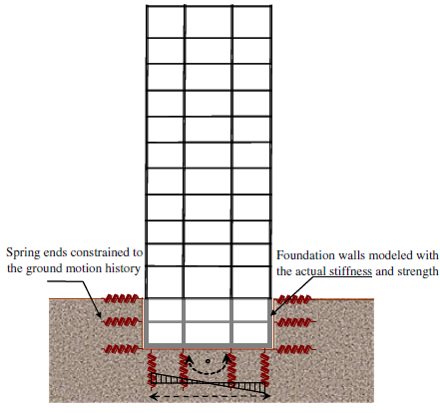

**Fig. 2.13** Most accurate model of a 54-storey building. (Finn et al., 2011)

In first model, the building was assumed to rest on rigid base, where there was no interaction between the soil and the basement walls. Its response was compared with the MA model and the drift ratio was reasonably good except in the basement levels where interstorey drift ratios were overestimated and, in the roof, it was underestimated.

In second model, the building was rested on a rigid base, but some passive lateral restrained was imposed on the basement walls by springs. Soil flexibility at the level of the base slab is neglected and soil flexibility along basement walls was simulated with horizontal springs. Drift ratios predicted by this model was very poor when compared with the MA model.

In third model, structure was assumed to be on a rigid base at ground surface and structure below were ignored. Response was good when compared to the MA model, but the drift ratio was overestimated by the third model at the ground and overestimated near the roof.

The seismic lateral pressures acting on the retaining walls were calculated using the Mononobe–Okabe (M–O) method. It was designed for hard retaining walls, however basement walls have varying degrees of flexibility and deformation depending on their depth. The M-O approach was used to design basement walls in British Columbia for seismic pressure. The goal of the basement wall study was to see how walls designed with PGA = 0.24 g would react when exposed to the new PGA = 0.46 g hazard. The strong ground motion database at the Pacific Earthquake Engineering and Research Center was used to select ground motion for analysis. The needed moment resistance of the basement wall for a friction angle of 330 and PGA = 0.24 g, as well as the design lateral earth seismic pressure distribution for the basement wall is shown in (Fig. 2.21).

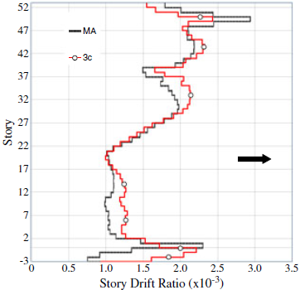Time history of the resultant force against the wall due to 1979 Imperial Valley Earthquake is shown in (Fig. 2.20).

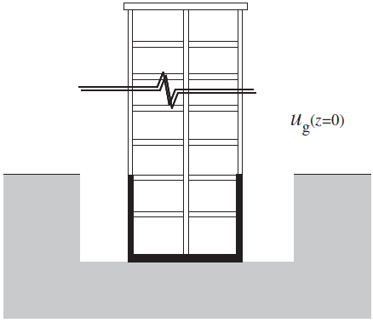

**Fig. 2.14** Simplest model of building with no soil–structure interaction (Finn et al., 2011)

**Fig. 2.15** Drift ratios for models MA and first model (Finn et al., 2011)

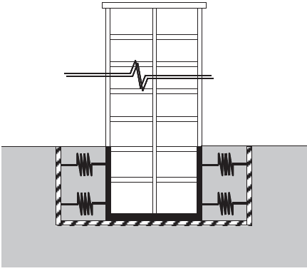

**Fig. 2.16** Second Model (Finn et al., 2011)

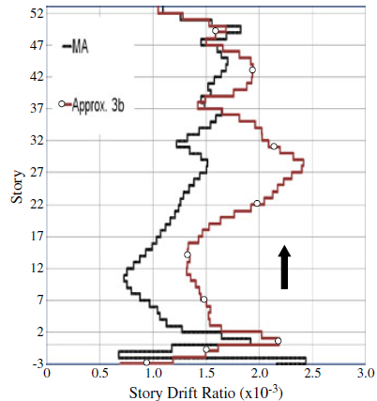

**Fig. 2.17** Drift ratios for models MA and second model (Finn et al., 2011)

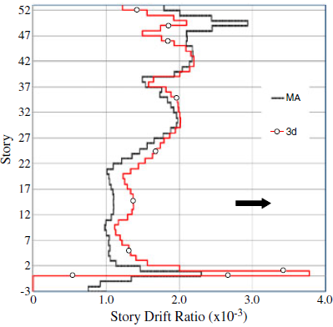

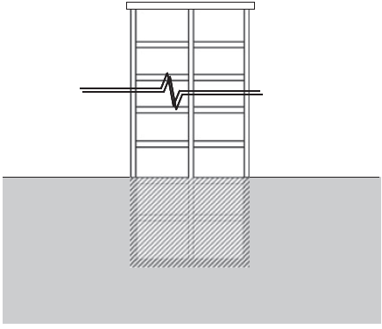

**Fig. 2.18** Third Model (Finn et al., 2011) **Fig. 2.19** Drift ratios for models MA and third model (Finn et al., 2011)

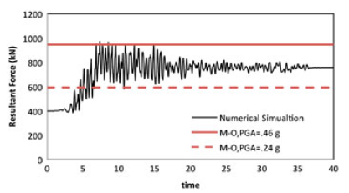

**Fig. 2.20** Time history of maximum force against the wall compared with M–O seismic forces (Finn et al., 2011)

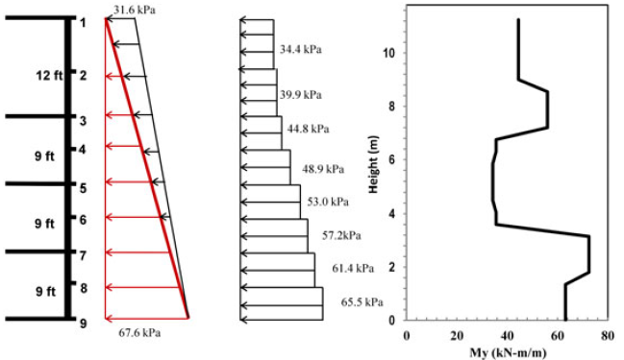

**Fig. 2.21** Distribution of the design lateral pressure along the height of the wall based on the current practice for a seismic event with PGA = 0.24 g and a backfill soil with friction angle of 3; the figure on the right shows the moment resistance distribution along the height of the wall. (Finn et al., 2011)

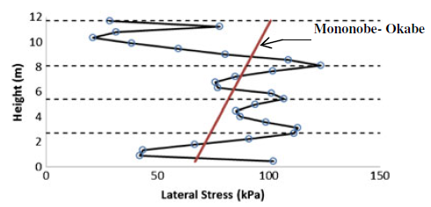

**Fig. 2.22** Pressure distribution at time of maximum force on the wall compared with linear Mononobe–Okabe maximum pressure. (Finn et al., 2011)

**2.2 Gap Areas**

Based on the literature review, it is noted that detailed study on the seismic behaviour of multistoried RC frame buildings with basement stories has not been carried out in the past. The influence of seismic soil-structure interaction on the possible failure modes of such buildings has not been investigated.

**2.3 Scope of Work**

In the present study, two multistoried RC building frames with and without basement stories, will be modelled using SAP2000 program. Initially, linear static analysis will be carried for the design of the structural components. Subsequently, monotonic displacement-controlled nonlinear static analysis will be carried on the two models to compare the seismic shear capacity, seismic displacement capacity and the possible failure modes.

**Chapter 3**

**Methodology**

**3.1 Modeling and Analysis**

**3.1.1 Building without Basement**

For carrying out the proposed work, the following salient steps was followed:

1. A five-storied RC frame building without unreinforced brick masonry infill walls is considered to be located in Seismic Zone V as per the Indian Earthquake Code IS:1893 (Part 1) – 2016 (BIS, 2016a). The plan dimensions are 15 m in length and 9 m in width, and the height of the superstructure is 15 m (Fig. 3.3(a)). The height of each story is 3 m, and the foundation story height is 2 m. The building is assumed to be founded on hard rock.

For the initial analysis, the sizes of the columns and beams are assumed to be 400 mm × 400 mm and 250 mm × 400 mm respectively. The thickness of the slab is considered to be 110 mm. The grades of concrete and steel reinforcement are assumed as M30 and Fe500 respectively.

2. The building frame is modelled using the computer program, SAP2000 (CSI, 2019).

Beams and columns are modelled using two noded frame elements. At the foundation level, the translational and rotational degrees of freedom at the bottom nodes of columns is completely restrained, making it act as a fixed joint. In each floor, all the nodes are constraints through diaphragm, so that all the nodes move by equal distance when load is applied, just like real slab behaviour.

3. Seismic loads to be applied are calculated using IS: 1893-2016, equivalent static method. Horizontal load is calculated for both X and Y direction and its value increases towards the upper story progressively. Load combination is considered as per IS:456-2000 (BIS, 2000) and IS: 1893-2016.

4. Linear static analysis is carried out for the model to obtain the design forces and the design moments. The building components, namely the (a) beams, and the (b) columns, is designed as per the Indian Concrete Code IS:456-2000 (BIS, 2000) and the Indian Ductile Detailing Code IS:13920-2016 (BIS, 2016b).

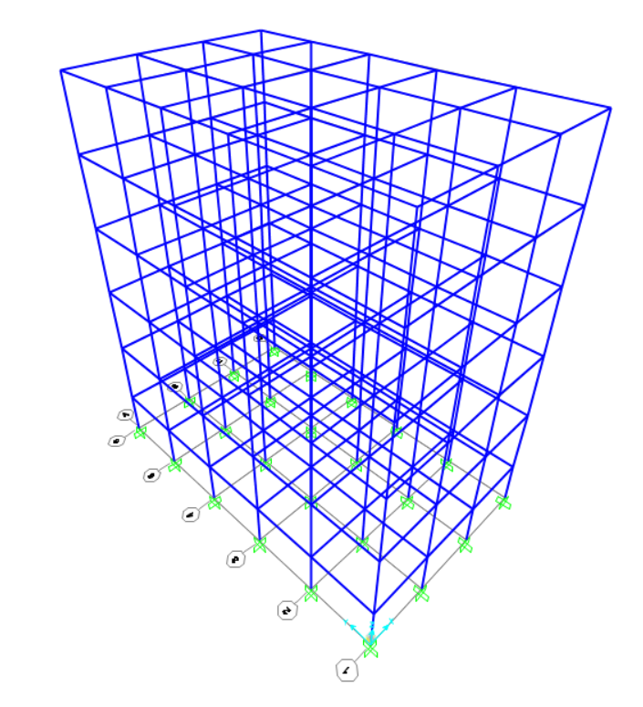

**Fig. 3.1** SAP 2000 model of five storied RC frame building with no basement

**3.1.2 Building with Basement**

1. The same building is again considered with the same floor plans in the superstructure but with three basement stories with each basement storey height being 3 m. The elevational view is shown in Fig. 3.3(b). At basement level, the additional bay of 3 m is considered to occur both along length and width of the building. Basement wall thickness to be considered is 200 mm.

2. Modelling is same as before but during modelling of shear walls, we consider shell elements for modelling it. This shell elements are discretized to get more accurate behaviour of shear wall. Horizontal forces are calculated as before using IS: 1893-2016, and is applied at the floors above the ground level. We didn’t consider the earth pressure on the shear wall as it will cause out of plane bending while the seismic load causes in-plane bending. Both are perpendicular to each other, so they don’t affect each other, hence we can neglect it. The same methodology for analysis and design, as mentioned above, is followed for the building with basement stories. In addition to the beams and the columns, the basement walls are also designed.

3. Monotonic displacement-controlled nonlinear static analysis is carried out on the building models, with and without basement stories, using lumped plastic hinges for modelling material nonlinearity. In SAP 2000, we use the section designer to input the detail of beams and columns. We also change the hinge properties, and provide hinge length as per the building we are designing.

The analysis provides the estimates of the lateral shear capacity and lateral displacement capacity during earthquake shaking. The nonlinear static behaviour is expected to provide detailed insight on the possible failure modes and the sequence of their occurrence.

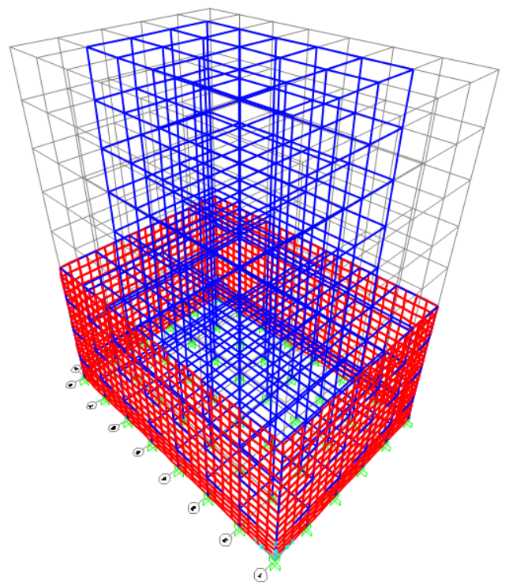

**Fig. 3.2** SAP 2000 model of five storied RC frame building with three basement stories

A

3.0m

B

C

D

3.0m

3.0m

3.0m

3.0m

3.0m

3.0m

3.0m

6

5

3.0m

3.0m

4

3

2

1

3.0m

3.0m

3.0m

3.0m

3.0m

3.0m

3.0m

3.0m

3.0m

3.0m

3.0m

1. (b)

**Fig. 3.3** Five-storied RC frame building with basement stories: (a) typical floor plan in superstructure and (b) elevational view.

**Chapter 4**

**Results**

**4.1 Base Shear for both the cases**

After doing the seismic load calculation using IS: 1893-2016, we obtained the base shear for building with no basement stories along X-direction as 434.192 KN and along Y-direction as 434.192 KN.

For building with basement stories, we obtained the base shear along X-direction as 1079.029 KN and along the Y-axis as 952.085 KN.

**4.2 Building without Basement**

**4.2.1 Design of beams and columns from Ground to 2nd Floor**

For beams and columns, we obtained the factored shear forces, axial forces and moments after analysis. From these forces and moments, we designed the beams and columns for critical beams and columns using IS: 456-2000 and IS:13920-2016.

For beams, we provide 4 numbers of 16 mm diameter main bars both at the top and bottom of the beams. For stirrups, provide 8 mm diameter bar at 75 mm spacing over a length of 2d = 708 mm and 8 mm diameter bar at 150 mm spacing over the remaining length of beam.

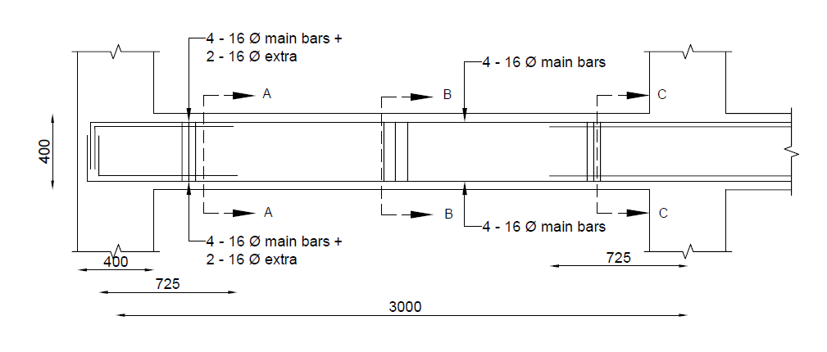

**Fig. 4.1** Detailing for beams from ground floor to 2nd floor

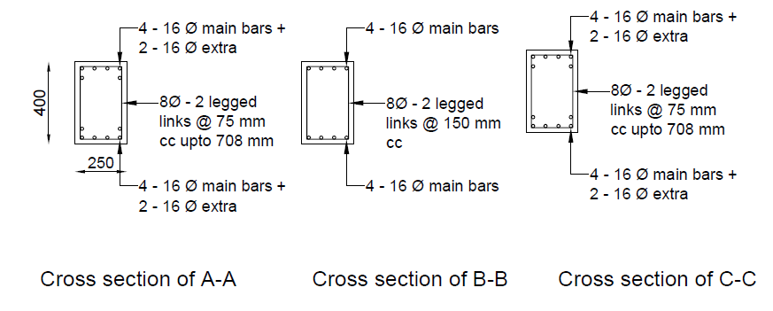

**Fig. 4.2** Cross sections of beams from ground floor to 2nd floor at different locations

For columns of ground floor to 2nd floor, we provide 4 numbers of 16 mm diameter and 4 numbers of 20 mm diameter main bars. For confining links, provide 8 mm diameter bar at 95 mm spacing over a length of lo = 450 mm and for nominal links, provide 8 mm diameter bar at 170 mm spacing over the middle portion of columns.

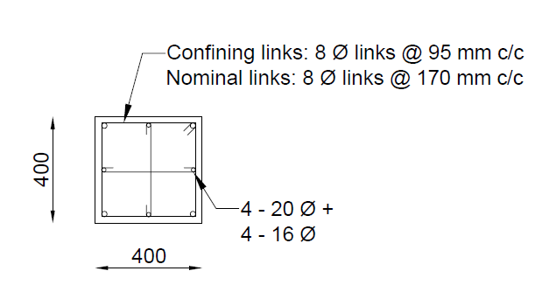

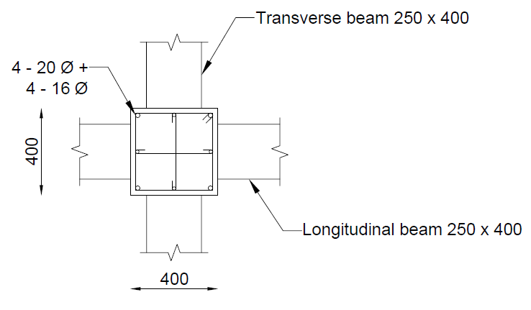

**Fig. 4.3** Detailing for Columns from ground floor to 2nd floor

**4.2.2 Design of beams and columns from 3rd to 5th Floor**

For beams, we provide the same detailing as we provided for ground to 2nd floor.



**Fig. 4.4** Detailing for beams from 3rd floor to 5th floor



**Fig. 4.5** Cross sections of beams from 3rd floor to 5th floor at different locations

For columns of 3rd floor to 5th floor, we provide 8 numbers of 16 mm diameter main bars. For confining links, provide 8 mm diameter bar at 95 mm spacing over a length of lo = 450 mm and for nominal links, provide 8 mm diameter bar at 150 mm spacing over the middle portion of columns.

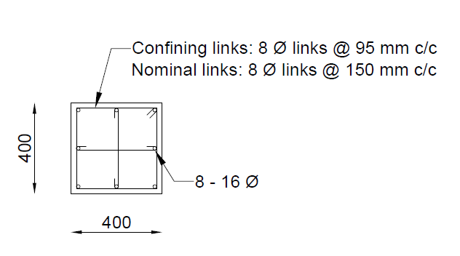

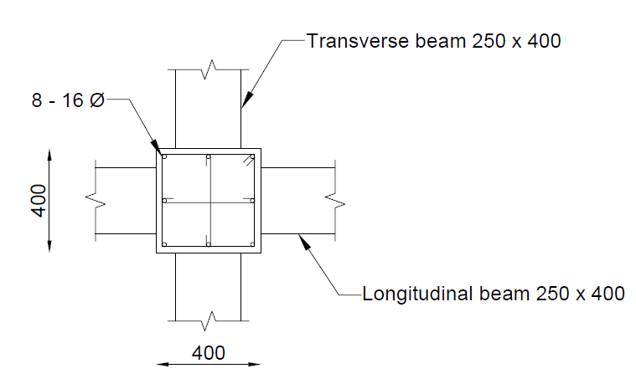

**Fig. 4.6** Detailing for Columns from 3rd floor to 5th floor

**4.3 Building with Basement**

**4.3.1 Design of beams and columns for and above ground floor**

For beams, we provide 5 numbers of 16 mm diameter main bars both at the top and bottom of the beams. For stirrups, provide 8 mm diameter bar at 70 mm spacing over a length of 2d = 718 mm and 8 mm diameter bar at 150 mm spacing over the remaining length of beam.

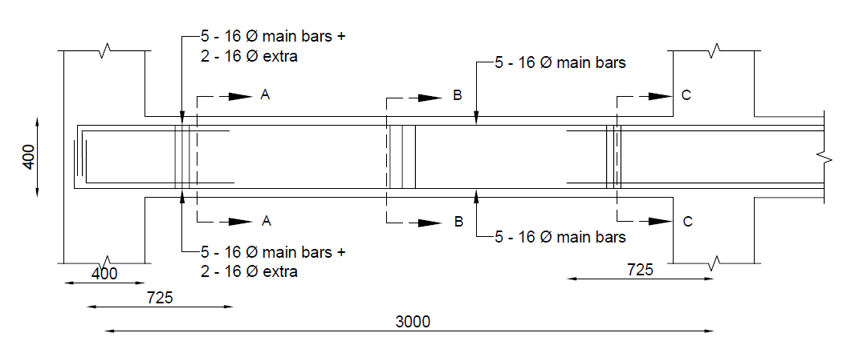

**Fig. 4.7** Detailing for beams for above the ground floor

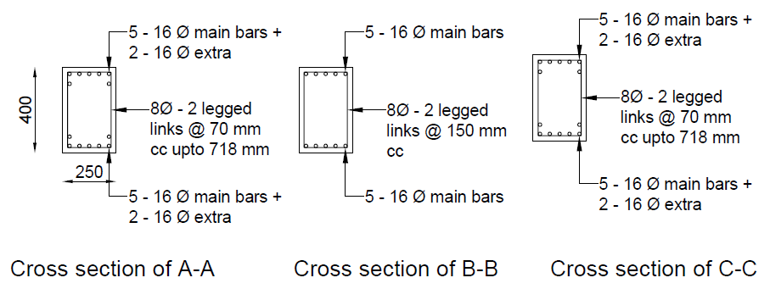

**Fig. 4.8** Cross sections of beams at different locations for above the ground floor

For columns of and above ground floor, we provide 4 numbers of 16 mm diameter and 4 numbers of 20 mm diameter main bars. For confining links, provide 8 mm diameter bar at 95 mm spacing over a length of lo = 450 mm and for nominal links, provide 8 mm diameter bar at 110 mm spacing over the middle portion of columns.

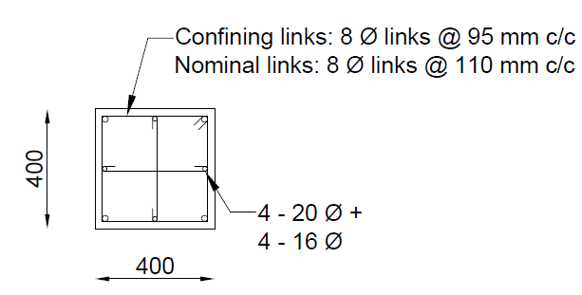

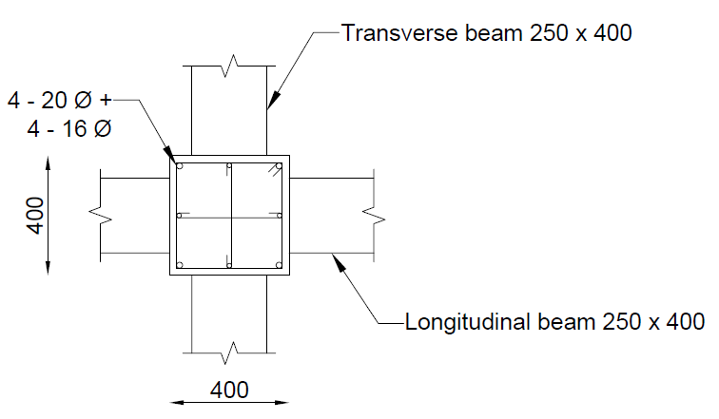

**Fig. 4.9** Detailing for Columns for above the ground floor

**4.3.2 Design of beams and columns for basement floors**

For beams, we provide 3 numbers of 16 mm diameter main bars both at the top and bottom of the beams. For stirrups, provide 8 mm diameter bar at 80 mm spacing over a length of 2d = 718 mm and 8 mm diameter bar at 150 mm spacing over the remaining length of beam.

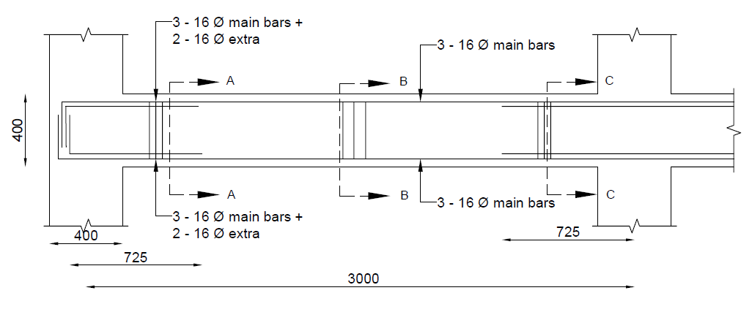

**Fig. 4.10** Detailing for beams for all the basement floors

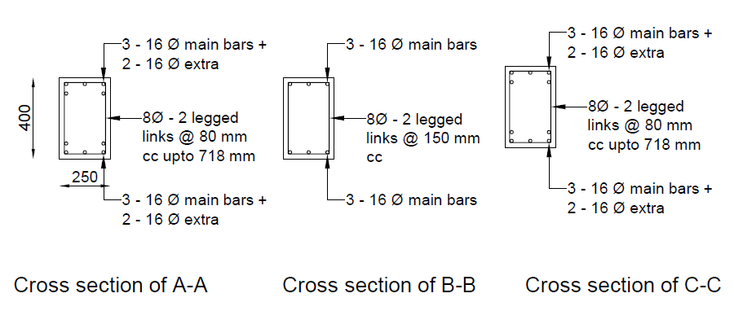

**Fig. 4.11** Cross sections of beams at different locations for all the basement floors

For columns of basement floors, we provide 8 numbers of 20 mm diameter main bars. For confining links, provide 8 mm diameter bar at 100 mm spacing over a length of lo = 450 mm and for nominal links, provide 8 mm diameter bar at 180 mm spacing over the middle portion of columns.

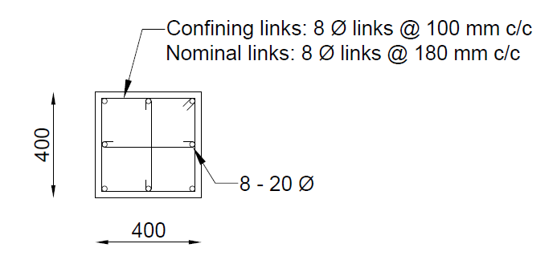

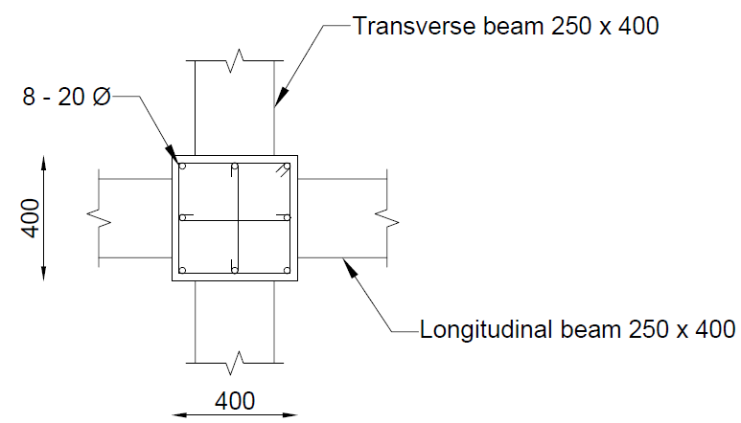

**Fig. 4.12** Detailing for Columns for all the basement floors

As for the Shear wall, after analysis we obtain the moment along both directions to be very small, one reason for this might be that the load is coming/distributing through columns toward foundation instead of distributing through shear wall.

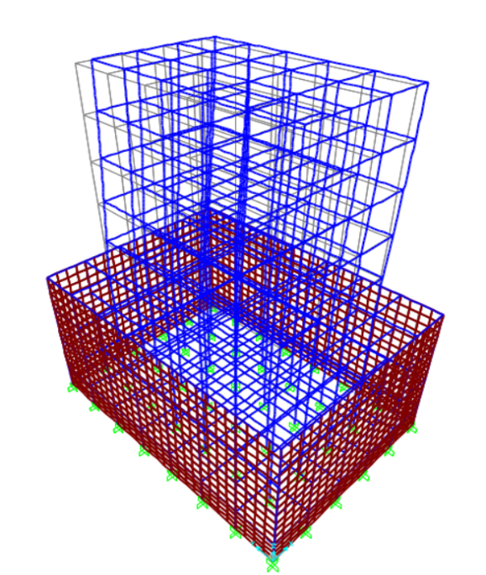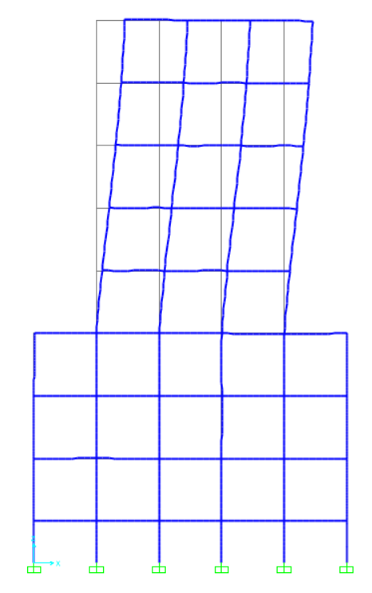

1. (b)

**Fig. 4.13** Deflected shape of the RC frame building with basement stories for seismic load along X-direction: (a) 3-D view of deflected shape and (b) side view of deflected shape.

**4.4 Pushover analysis**

**4.4.1 For building without basement stories**

After doing the pushover analysis for the building without basement stories we obtained the base shear vs displacement as shown in Fig. 4.14. Initially the base shear increases linearly with displacement, and then it started to slow down its increase in base shear due to beginning of formation of hinges. After some more displacement, the base shear starts to decrease because the hinges of beams start to collapse *i.e.,* in the region C to D. The yellow dots in the Fig. 4.15 shows the collapsing of hinges.

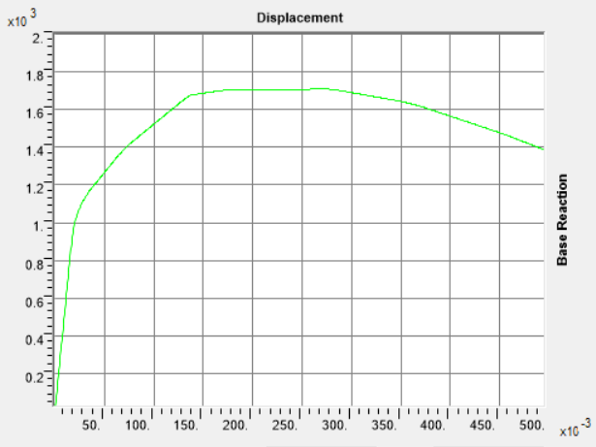

**Fig. 4.14** Pushover curve: Base reaction vs displacement

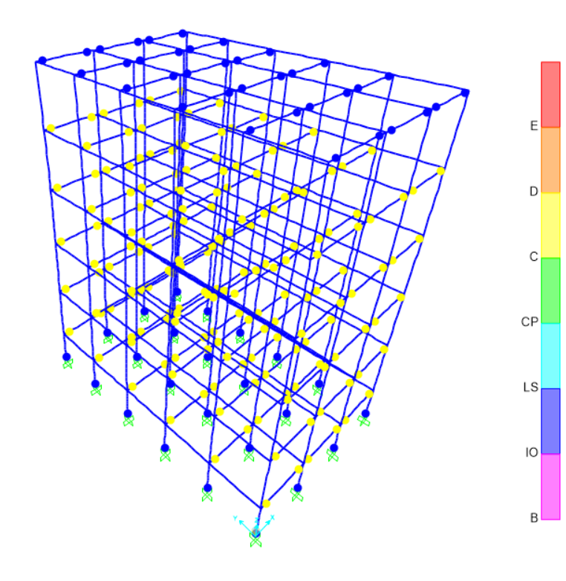

**Fig. 4.15** Deflected shape of the RC frame building with basement stories for pushover analysis at step 994.

**Chapter 5**

**Summary**

**5.1 Conclusion**

After comparing the results of both the buildings analysis and design, we obtained that the base shear for building with basement stories is more than the building with no basement. Beams of basement floors requires less reinforcements as compare to upper stories and building with no basement because of shear wall. Shear wall reduces the load and moments acting on the beams in the basement floors. The reinforcement detailing and requirement for columns is almost similar in both the buildings.

In the non-linear analysis of building with no basement stories, the maximum shear capacity of the building is found to around 1.7 × 103 KN from pushover analysis. After a certain displacement, base shear starts to decrease due to the collapsing of hinges.

**5.2 Future Scope of work**

Pushover analysis for the building with basement stories shall be perform for the finding the shear capacity of the building. Results of non-linear analysis from both the buildings should be compare to find the resistance provided by basement and shear walls from that of regular RC frame buildings with no basements.

**References**

1. Finn, W. L., Pandey, B. H., & Ventura, C. E. (2011). Modeling soil–foundation–structure interaction. *Wiley Online Library*, 16.

2. Mansour, M. F., Abdel-Motaal, M. A., & Elsaba, A. A. (2021). Seismic response of basement walls as partially-yielding retaining walls. *ScienceDirect*, 13.

3. Ren, X., Bai, Q., & Yang, C. (2017). Seismic behavior of tall buildings using steel–concrete composite columns and shear walls. *Wiley Online Library*, 13.

4. ATC (2010), PEER/ATC-72-1 Modelling and Acceptance Criteria for Seismic Design and Analysis of Tall Buildings, *Applied Technology Council*, Redwood City, USA

5. BIS (2000), Indian Standard Plain and Reinforced Concrete – Code of Practice IS: 456 – 2000, *Bureau of Indian Standards*, New Delhi, India

6. BIS (2016a). Indian Standard Criteria for Earthquake Resistant Design of Structures. Part 1: General Provisions for all structures and specific provisions for buildings, IS:1893-2016, *Bureau of Indian Standards*, New Delhi, India

7. BIS (2016b), Indian Standard Code of Practice for Ductile Detailing of Reinforced Concrete Structures Subjected to Seismic Forces, IS:13920-2016, *Bureau of Indian Standards*, New Delhi, India

**Annexure A**

**Beam design of building without basement**

Max Shear, V = 73.158 KN *(from SAP 2000 analysis)*

Max Mu = 84.914 KN-m *(from SAP 2000 analysis)*

Given, b = 250 mm

D = 400 mm

M30, Fe500

**A-1 Various Checks**

**A-1.1 Check for Axial Stress -**

Factored Axial Stress = 0 MPa < 0.08fck

So, Design as flexural member.

**A-1.2 Check for Member Size -**

Width of beam, b = 250 mm > 200 mm *(OK)… (Clause 6.1.2; IS 13920:2016)*

Dept of beam, D = 400 mm

= = 0.625 > 0.3 *(OK)… (Clause 6.1.1; IS 13920:2016)*

Span, L = 3000 mm

= = 7.5 > 4 *(OK)… (Clause 6.1.3; IS 13920:2016)*

**A-1.3 Check for Limiting Longitudinal Reinforcement –**

Assuming, Diameter of main bars = 16 mm, Diameter of stirrups = 8 mm

Nominal cover = 30 mm

Effective depth = 400 – 30 – 8 – (16/2)

= 354 mm

Minimum reinforcement

= 0.24 * = 0.24 * *… (Clause 6.2.1(b); IS 13920:2016)*

= 0.26 %.

= 0.26 x 250 x 354/100

= 230.1 mm2

Maximum reinforcement

= 2.5 % *… (Clause 6.2.2; IS 13920:2016)*

= 2.5 * 250 * 354/100

= 2212.5 mm2

**A-2 Design of Flexure**

Mu = 84.912 KN-m

Mu, lim = 0.133fckbd2 = 0.133 * 30 * 250* (354)2

= 125.003 KN-m > 84.912 KN-m *(Singly-reinforced)*

Now,

= = 2.71

From Table-4 for M30 and Fe500, of SP: 16

Pt = 0.707 (after interpolation)

Ast = Pt * bd /100

= 0.707 * 250 * 354 /100 = 625.695 mm2

**Ast, min < Ast < Ast, max** (OK)

Number of bars = =

= 3.11 ≈ 4 number of bars.

So, Ast provided = 4 * * dia2 / 4 = * 162

= 804.25 mm2

Providing 4 nos. of 16 mm dia bars (Ast = 804.25 mm2)both at the top and the bottom.

Pt provided = 0.908

**A-3 Design of Shear**

Shear Force Due to Plastic Hinge Formation at the ends of the Beam

*(Clause 6.3.3; IS 13920:2016)*

Vswaytoright =

Vswaytoleft =

From Table-56 of SP: 16, for Pt & Pc =0.908 %, d’/d = 0.13

= 6.94

= 6.94 * 250 * 3542 / 106

= 217.423 KN-m *(for both ends)*

= 6.94 * 250 * 3542 / 106

= 217.423 KN-m *(for both ends)*

So, Shear is –

Vswaytoright =

= 1.4 * (217.423 + 217.423) / 3

= 202.93 KN

Vswaytoright =

= 1.4 * (217.423 + 217.423) / 3

= 202.93 KN

We have DL = Triangular dead load + self-load

= 35.4375 + 25 * 0.25 * 0.4 * 3

= 42.9375 KN

LL = 16.875 KN

Shear at left end for sway to right,

Vu, a = -

= 1.2 * (42.9375 + 16.875) / 2 – 202.93

= 167.0425 KN

Shear at left end for sway to left,

Vu, a = +

= 1.2 * (42.9375 + 16.875) / 2 + 202.93

= 238.8175 KN

Shear at right end for sway to right,

Vu, a = +

= 1.2 * (42.9375 + 16.875) / 2 + 202.93

= 238.8175 KN

Shear at left end for sway to left,

Vu, a = -

= 1.2 * (42.9375 + 16.875) / 2 - 202.93

= 167.0425 KN

As per Clause 6.3.3 of IS 13920:2016, the design shear force to be resisted shall be the maximum of:

i) Calculated factored shear forces as per analysis.

ii) Shear forces due to formation of plastic hinges at both ends of the beam plus factored gravity load on the span.

Design shear, Vu = 238.8175 KN

The required capacity of shear reinforcement at the left end, right end and at mid-span of the beam is: 238.8175 KN

= = = 2.92 N/mm2

= 3.5 N/mm2 *(for M30) Table 30 of IS:456*

From table 19 of IS:456

= 0.634 N/mm2 *(for Pt = 0.908 and M30)*

< < *(shear reinforcement should be provided greater than minimum)*

Vus = ( - ) *b*d

= (2.92 – 0.634) * 250 * 354

= 202.311 KN

Adopting 8 mm two legged vertical stirrups

Asv = 100.53 mm2

Sv = 0.87*fy*Asv*d / Vus

= 0.87 * 500 * 100.53 * 354 / (202.311 * 103)

= 76.51 mm

Spacing of links over a length of 2d at either end of beam shall not exceed –

a) d/4 = 354/4 = 88.5

b) 6 times diameter of smallest longitudinal bar = 6 * 16 = 96 mm

c) 100 mm

So, Providing spacing of 75 mm over a length of 2d at either end of beam.

Over the remaining length of the beam, vertical links shall be provided at a spacing not exceeding d/2 = 354/2 = 177 mm

Providing spacing of 150 mm over the remaining length of beam.

**Annexure B**

**Column design of building without basement from ground floor to 2nd floor**

We have Pu = 689.188 KN *(from SAP 2000 analysis)*

Vx = 45.374 KN *(from SAP 2000 analysis)*

Vy = 31.303 KN *(from SAP 2000 analysis)*

Mx = 49.9073 KN-m *(from SAP 2000 analysis)*

My = 72.4862 KN-m *(from SAP 2000 analysis)*

**B-1 Various checks**

**B-1.1 Check for member size**

Width of column, B = 400 mm >= 300 mm (OK)

Also, minimum dimension of column = 400 mm >= 20 times the largest diameter of beam longitudinal reinforcement = 20 x 16 = 320

(OK) *… (Clause 7.1.1 of IS 13920:2016)*

Depth of column, D = 400 mm

B/D = 400/400 = 1 > 0.4 (OK) *… (Clause 7.1.2; IS 13920:2016)*

Span, L = 3000 mm

As per Figure 27 of IS 456:2000, the effective length is taken as minimum 1.2 times the

unsupported length.

L / D = = 7.8 < 12 *i.e., Short Column*

*(OK) (Clause 25.1.2 of IS 456: 2000)*

**B-1.2 Check for limiting longitudinal reinforcement**

Minimum reinforcement = 0.8%

= 0.8 * 400 * 400 / 100

= 1280 mm2

Maximum reinforcement = 6%

= 6 * 400 * 400 / 100

= 9600 mm2 *…* *(Clause 26.5.3.1 of IS 456: 2000)*

**B-2 Design of Column**

Assuming effective cover = d’ = 60 mm

Diameter of main bars = 20 mm

So, d’ / d = 60 / 400

= 0.15

Design for Earthquake in X-direction

Assuming Pt = 1 %

= = 0.033

Pu = 689.188 KN

Mx = 49.907 KN-m

= = 0.143

From Chart 49 of IS: SP 16

= 0.08

Mux,1 = 0.08 * 30 * 400 * 400 * 400

= 153.6 KN-m

Design for Earthquake in Y-direction

Assuming Pt = 1 %

= = 0.033

Pu = 689.188 KN

My = 72.486 KN-m

= = 0.143

From Chart 49 of IS: SP 16

= 0.08

Muy,1 = 0.08 * 30 * 400 * 400 * 400

= 153.6 KN-m

Longitudinal Steel

Pt = 1 %

Required steel = 1 * 400 * 400 / 100

= 1600 mm2

Providing 4 – 20 & 4 – 16 mm of diameter bars

Asc provided = (4 * 3.14 * 202 / 4) + (4 * 3.14 * 162 / 4)

= 2060.88 mm2

So, Pt provided = * 100

= 1.28 %

= 1.28/30 = 0.043

**B-2.1 Checking for Critical Combination with Earthquake in X Direction (Longitudinal direction)**

Width = 400 mm, Depth = 400 mm

Pu = 689.188 KN

Mux = 49.907 KN-m

Eccentricity = Clear height of column/500 + lateral dimension / 30 …*(Clause 25.4 of IS 456:2000)*

= ((3000 – 400) / 500) + (400 / 30)

= 18.53 mm < 20 mm

So, design eccentricity = 20 mm

Muy = 689.188 * 0.020 = 13.78 KN-m

For = 0.143 and p/fck = 0.043, from chart 49 of SP: 16, we obtain

= 0.095

Mux, 1 = 0.095 * 30 * 400 * 400 *400 / 106

= 182.4 KN-m

Muy, 1 = 0.095 * 30 * 400 * 400 *400 / 106

= 182.4 KN-m

Puz = 0.45fckAc + 0.75fyAsc *… (Clause 39.6 of IS 456:2000)*

= 0.45fckAg + (0.75fy – 0.45fck) Asc

= 0.45 * 30 * 400 * 400 + (0.75 * 500 – 0.45 * 30) * 2060.88

= 2905.01 KN

Pu / Puz = 689.188 / 2905.01 = 0.24

The constant which depends on factored axial compression resistance Puz is evaluated as

= 1 + * (2 – 1)

= 1.067

Using the interaction formula of clause 39.6 of IS 456: 2000

+ =

= 0.314 < 1 (OK)

**B-2.2 Checking for Critical Combination with Earthquake in Y Direction (Transverse direction)**

Width = 400 mm, Depth = 400 mm

Pu = 689.188 KN

Muy = 72.4862 KN-m

Eccentricity = Clear height of column/500 + lateral dimension / 30 …*(Clause 25.4 of IS 456:2000)*

= ((3000 – 400) / 500) + (400 / 30)

= 18.53 mm < 20 mm

So, design eccentricity = 20 mm

Mux = 689.188 * 0.020 = 13.78 KN-m

For = 0.143 and p/fck = 0.043, from chart 49 of SP: 16, we obtain

= 0.095

Mux, 1 = 0.095 * 30 * 400 * 400 *400 / 106

= 182.4 KN-m

Muy, 1 = 0.095 * 30 * 400 * 400 *400 / 106

= 182.4 KN-m

Puz = 0.45fckAc + 0.75fyAsc *… (Clause 39.6 of IS 456:2000)*

= 0.45fckAg + (0.75fy – 0.45fck) Asc

= 0.45 * 30 * 400 * 400 + (0.75 * 500 – 0.45 * 30) * 2060.88

= 2905.01 KN

Pu / Puz = 689.188 / 2905.01 = 0.24

The constant which depends on factored axial compression resistance Puz is evaluated as

= 1 + * (2 – 1)

= 1.067

Using the interaction formula of clause 39.6 of IS 456: 2000

+ =

= 0.437 < 1 (OK)

**B-3 Design of Shear**

Permissible shear stress = = 0.716 MPa *(From Table 19 of IS 456)*

Considering lowest Pu = 200.222 KN

= 1 + = 1 +

= 1.125 < 1.5 (OK) *… (Clause 40.2.2 of IS 456: 2000)*

So, = 1.125 * 0.716

= 0.806 MPa

Effective depth in X direction = 400 – d’ = 400 - 60

= 340 mm

*Vc* = 0.806 * 400 * 340 / 1000

= 109.616 KN

Effective depth in Y direction = 400 – d’ = 400 - 60

= 340 mm

*Vc* = 0.806 * 400 * 340 / 1000

= 109.616 KN

**B-3.1 Shear Force Due to Plastic Hinge Formation at Ends of Beam**

Vu =

At both longitudinal and transverse beam, the percentage of steel at top and bottom of beam is 0.908%

So, hogging and sagging moment capacities is 217.423 KN-m for both.

Vu = 1.4 * (217.423 + 217.423 / 3

= 188.433 KN *(for both X and Y direction)*

**B-3.2 Design Shear**

The design shear force for the column shall be the higher of the calculated factored shear force as per analysis and the shear force due to plastic hinge formation in either of the transverse or the longitudinal beam.

So, design shear in both X and Y direction are 188.433 KN

**B-3.3 Detailing of Transverse reinforcements**

Vs = Vu - Vc

= 188.433 – 109.616

= 78.817 KN

Spacing of 2-legged 8 mm diameter bars is

Sv = 0.87*fy*Asv*d / Vs

= 0.87 * 500 * 2 * 3.14 * (8/2)2 * 340 / 78817

= 188.64 mm

***Nominal Links***

The spacing of hoops shall not exceed half the least lateral dimension of the column i.e., 400/ 2 = 200 mm. *… (Clause 7.4.2; IS 13920:2016)*

Provide 8 mm diameter links @ 170 c/c in middle portion of the column.

***Confining Links***

The area of cross section, *Ash*, of the bar forming rectangular hoop, to be used as special confining reinforcement shall not be less than

*Ash* = max of &

*… (Clause 7.6.1(c) of IS 13920:2016)*

Here, Ag = 400 * 400 = 160000 mm2

Ak = (400 – 2 * 42) * (400 – 2 * 42)

= 99856 mm2

h = (400 – 2 * 60) / 2

= 140 mm

Ash = 2 * 3.14 * (8/2)2

= 100.53 mm2

So, *Sv* =

= 110.4 mm

Link spacing for confining zone shall not exceed 6 times the diameter of the smallest longitudinal reinforcement bars = 6x16 = 96 mm

*… (Clause 7.6.1(b) of IS 13920:2016)*

Provide 8mm diameter confining links @ 95 mm c/cfor a distance lo, which shall not be

less than:

a. Larger lateral dimension = 400 mm

b. 1/6 of clear span = (3000 – 400) / 6 = 433.33 mm

c. 450 mm *… (Clause 7.6.1 (a) of IS 13920:2016)*

Provide confining reinforcement for a distance of lo = 450 mm on either side of the joint.